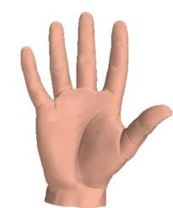
Five Things…

Answer the following questions and share your answers with your clasmates:

I've always wondered about...

If I could stay at any age, I'd like to be... because…..

If I had the day off tomorrow, I would...

The most fun thing I did this year is...

I've always wanted to (but never had the courage to) ....

