Island Time task sheet: My Cultural Portrait

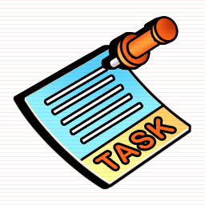  What? | Write a cultural self portrait – what are your cultural backgrounds?  Purpose – to communicate facts and your feelings about your cultural background Audience – your teachers and classmates Form – a piece of prose, divided into paragraphs, accompanied by 3-4 suitable images
Which skills? | Communication – sentence formation, paragraph organisation
How? | - Look at your mindmap from today - which aspects will you concentrate on?  - In which order will you cover those aspects?  - Look at the link to ‘key question and extension questions’  - Will you just focus on the key question, or will you try to address an extension question as well? (be ambitious but realistic!)
Successful if... | - Organisation  - Is each paragraph about a particular aspect of your life?  - Do all the points in the paragraph relate to the topic?  - Are the paragraphs well ordered?  - PEE!  - Punctuation  - Do you start each sentence in the correct place and avoid run-on sentences?  - Capital letter to start each sentence, correct punctuation to end  - capital letters for proper nouns  - correct use of commas (to separate lists and to chunk information)  - apostophes! (it’s / its / Brian’s / Brian / Chris’ / Chris)  - Presentation  - Clear and tidy – not too fussy!  - An interesting title  - The name of the author  - A poignant image to accompany the text

