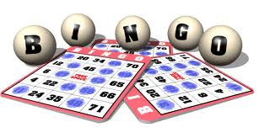

People bingo

Somebody who was born in Hong Kong | Somebody who is going to walk to school | Somebody who has played a sports match at Hong Kong Stadium | Somebody who speaks a language other than English to their parents
Somebody whose brother or sister is in Year 9 | Somebody who has at least one parent who studied at Island School | Somebody who did not go to an ESF primary school | Somebody who can play more than one musical instrument
Somebody who does not eat meat | Somebody who is left-handed | Somebody who stayed in Hong Kong in the summer | Somebody who has been to at least three continents

- Write the full name of a different person in each box
- Try to complete a whole line, or even better, a ‘full house’

